Module 7 Java-RDBMS & Amp Database Programming With JDBC
Q .1 what is JDBC (Java Database Connectivity)?
Ans: JDBC, or Java Database connectivity, is an application programming interface (API) for the Java Programming language that defines how a client may access a database. It is java-based data access technology used for connecting java applications to various relational database management systems (RDBMS) and other data sources.
Q.2 Importance of JDBC in Java Programming
Ans:
- Standardized Database Access :
JDBC provides a consistent and standardized way for Java applications to connect to various relational databases, such as Oracle, MySQL, SQL Server, and PostgreSQL. This standardization simplifies database interaction for developers, as they can use a single API regardless of the underlying database system.
- Database Agnostic Code :
By abstracting the complexities of different database systems, JDBC allows developers to write database-independent code. This means that an application developed with JDBC can potentially work with different databases by simply changing the database driver, without requiring significant code modifications. This enhances portability and flexibility.
- Core for Data-Driven Applications :
Most modern applications require data storage and retrieval. JDBC forms the foundation for building data-driven applications in Java, enabling functionalities like fetching data, inserting new records, updating existing information, and deleting data from databases.
- Executing SQL Queries :
JDBC facilitates the execution of SQL queries and statements directly from java code. This includes DDL (Data Definition Language) commands for creating and modifying database schemas, DML (Data Manipulation Language) commands for manipulating data within tables.
- Result Set Processing :
After executing queries, JDBC provides mechanisms to retrieve and process the result sets obtained from the database. This allows java applications to access and utilize the data returned by queries.
Q.3 JDBC Architecture: Driver Manager, Driver, Connection, Statement, and Result Set
Ans:
- Driver Manager:
This class manages the available JDBC drivers. It acts as the primary interface for connecting to a database by locating and loading the appropriate driver based on the provided JDBC URL. Once a connection is established, the Driver Manager’s role in that specific connection typically concludes.
- Driver:
- A JDBC driver is a software component that translates standard JDBC API calls into the database-specific communication protocols. Each database system (e.g., MySQL, PostgreSQL, and Oracle) requires its own specific JDBC driver to enable java applications to interact with it.

- Connection:
The Connection object represents an active session with a specific database. It is established by the Driver Manager and serves as the conduit for all database operations, including creating statements, executing queries, and managing transactions.
- Statement:
The Statement object is used to execute static SQL statements. It allows a Java application to send SQL queries to the database and receive results. There are also specialized Statement types like Prepared Statement for pre-compiled SQL statements and Callable Statement for executing stored procedures.
- Result Set:
The Result Set object represents the tabular data returned by a SQL query, typically a SELECT Statement. It provides methods to navigate through the row of the result set and retrieve data from individual columns in a type-safe manner. The Result Set maintains a cursor that points to the current row, allowing sequential or sometimes scrollable access to the data.
Q.4 Overview of JDBC Driver Types:
- Type 1: JDBC-ODBC Bridge Driver
- Type 2: Native-API Driver
- Type 3: Network Protocol Driver
- Type 4: Thin Driver
Ans:
Type 1: JDBC-ODBC Bridge Driver:
Type 1 driver or JDBC-ODBC Bridge Driver uses ODBC driver to connect to the database. The JDBC-ODBC bridge driver converts JDBC method calls into the ODBC function calls. Type-1 driver is also called Universal driver because it can be used to connect to any of the databases.
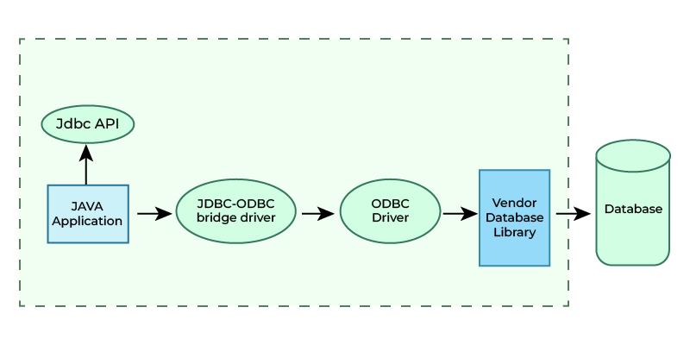
JDBC-ODBC Bridge Driver
Type 2: Native-API Driver (Partially Java Driver):
The Native API Driver uses the client-side libraries of the database. These driver converts JDBC method calls into native calls of the database API. In order to interact with different database, this driver needs their local API, that’s why data transfer is much more secure as compared to type-1 driver. This driver is not fully written in java that is why it is also called Partially Java driver.
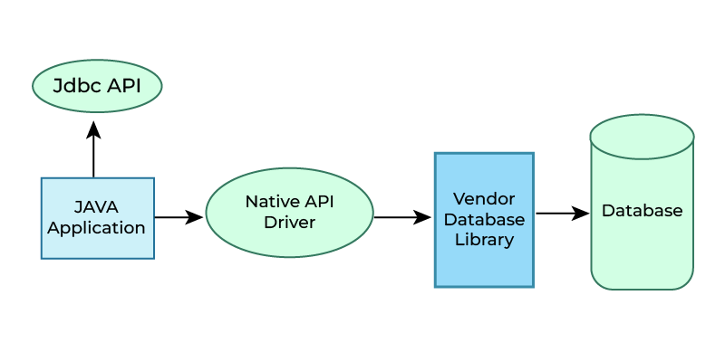
Native API Driver (Partially Java Driver)
Type 3: Network Protocol Driver (Fully Java Driver):
The Network Protocol driver uses middleware (application server) that converts JDBC calls directly or indirectly into the vendor-specific database protocol. Here all the database connectivity drivers are present in a single server, hence no need of individual client-side installation.
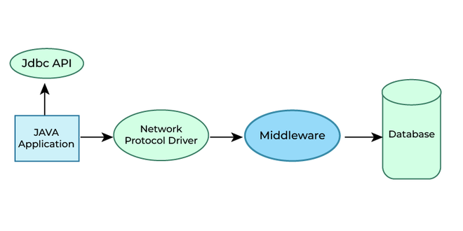
Network Protocol Driver (Fully Java Driver)
Type 4: Thin Driver:
Type 4 driver is also called native protocol driver. This driver interact directly with database. It does not require any native database library, that is why it is also known as Thin Driver.
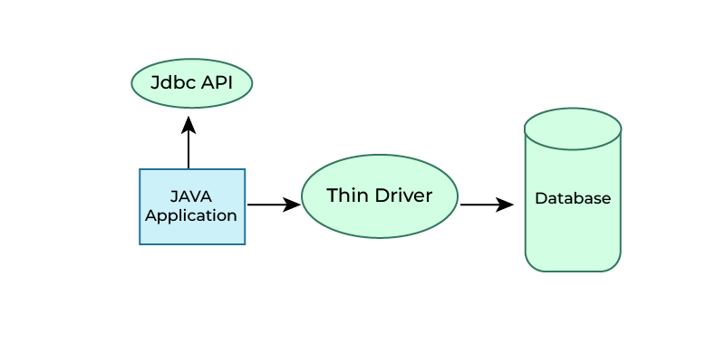
Thin Driver
Q.5 Comparison and Usage of Each Driver Type
Ans:
Q.6 Step-by-Step Process to Establish a JDBC Connection:
1. Import the JDBC packages
2. Register the JDBC driver
3. Open a connection to the database
4. Create a statement
5. Execute SQL queries
6. Process the result set
7. Close the connection
Ans:
Import the JDBC packages:
The first step requires importing the necessary JDBC classes and interfaces. These are the primarily found within the java.sql package.
Register the JDBC driver:
The specific JDBC driver for the database being used needs to loaded and registered. This typically involves using Class.forName () to load the driver class.
Open a connection to the database:
Once the driver is registered, a connection to the database can be established using the DriverManager.getConnection () method. This method requires the database URL, username, and password.

Create a statement:
A Statement object is created from the Connection object. This object is used to execute SQL queries.
Execute SQL queries:
SQL queries are executed using methods of the Statement object, such as executeQuery () for SELECT statement or executeUpdate () for INSERT, UPADATE, or DELETE statements.
Process the result set:
If a SELECT query was executed, the ResultSet object contains the retrieved data. This data can be iterated through and processed.
Close the connection:
Finally, it is crucial to close the ResultSet, Statement, and Connection objects in a finally block to release database resources and prevent resources leaks.
Q.6 Overview of JDBC Statements:
Ans: CallableStatement:
Purpose: Used for executing precompiled SQL Statements with parameters, particularly for DML operations like INSERT, UPDATE, or DELETE.
Compilation: SQL Statements are precompiled by the database when the PreparedStatement object is created. This precompilation allows for faster execution when the same query is executed multiple times with different parameter values.
Security: Offers protection against SQL injection attacks by using parameter markers (?) and setting values through type-safe setter method s
PreparedStatement:
Statement: Executes simple SQL queries without parameters.
Differences between Statement, PreparedStatement, and CallableStatement
Statement | PreparedStatement | CallableStatement
Purpose: Used for executing static SQL queries that do not change or are executed only once. | Purpose: Used for executing parameterized SQL queries, especially when the same query needs to be executed multiple times with different values. | Purpose: Used specifically for executing stored procedures and functions in the database.
Feature: It does not support parameterization, meaning values must be directly embedded in the SQL string. This makes it vulnerable to SQL injection if input is not properly sanitized. | Feature: Supports placeholders (e.g.,?) for parameters, which are then set programmatically. This prevents SQL injection as the parameters are sent separately from the SQL command. | Feature: Extends PreparedStatement and provides methods for handling IN, OUT, and INOUT parameters, as well as return values from stored procedures.
Performance: Generally less efficient to repeated execution of similar queries as the database needs to parse, compile, and optimize the query every time. | Performance: Offers better performance than Statement for repeated executions because the query is pre-compiled and optimized by the database only once, and subsequent executions only require sending the parameter values. | Performance: Efficient for executing stored procedures as they are pre-compiled and optimized within the database itself.

Q.7 Insert: Adding a new record to the database.
Ans: Adding a record to a database, commonly referred by to an “insert” operation, is typically performed using the INSERT INTO SQL statement allows for the addition of one or multiple rows of data into a specified table.
Q.8 Update: Modifying existing records.
Ans: In SQL, modifying existing records and altering table structures are fundamental operations that allow update data and adjust the database schema. The UPDATE command is used to change the values of existing records in a table, enabling us to correct or update data as needed.
Q.9 Select: Retrieving records from the database.
Ans: Retrieving records from a database is primarily accomplished using the SELECT statement in Structured Query Language (SQL). This statement allows users to specify which data they wish to retrieve and from which tables.
Q.10 Delete: Removing records from the database.
Ans: “Delete” refers to the SQL command used to permanently remove rows (records) from a database table, while retaining the table structure. It’s Data Manipulation Language (DML) command that utilizes the DELETE FROM table_name syntax, with the crucial WHERE clause to specify which records to remove. Omitting the WHERE clause delete all rows from the table, so it’s essential to use a condition to target specific records for deletion.
Q.11 What is ResultSet in JDBC?
Ans: In JDBC (Java Database Connectivity), a ResultSet is an object that represents the result of executing a SQL query on a database. It essentially acts as table of data, holding the rows and columns returned by the query.
Q.12 Navigating through ResultSet (first, last, next, previous)
Ans: Navigating through ResultSet in JDBC involves using specific methods to move the cursor, which points to the current row of data.
Navigation Methods:
next ():
Moves the cursor to the next row. It returns true if a valid row exists, and false if the cursor is positioned after the last row. This is the most common method for iterating through a ResultSet.
previous ():
Moves the cursor to the previous row. It returns true if a valid row exists, and false if the cursor is positioned before the first row. This method is only available for scrollable ResultSet objects.
first ():
Moves the cursor to the first row of the ResultSet. This method is only available for scrollable ResultSet objects.

last ():
Moves the cursor to the last row of the ResultSet. This method is only available for scrollable ResultSet objects.
Q.13 Working with ResultSet to retrieve data from SQL queries
Ans: Retrieving data from SQL queries using a ResultSet in JDBC involves the following steps:
- Establish a Database Connection
- Create a Statement or PreparedStatement
- Execute the Query
- Process the ResultSet
- Close Resources
Q.14 What is Database Metadata?
Ans: Metadata in a database is “data about data.” It provides descriptive and structural information about the data stored within the database, rather than being the actual content of the data itself. This information helps in understanding, organizing, managing, and utilizing the data effectively.
Q.15 Importance of Database Metadata in JDBC
Ans: Database metadata in JDBC, accessed primarily through the java.sql.DatabaseMetaData interface, is cruciacl for developing robust, flexible, and self-aware database applications. Its importance stems from its ability to provide comprehensive information about the database systems and its structure at runtime.

Q.16 Methods provided by Database Metadata (getDatabaseProductName, getTables, etc.)
Ans: The Database Metadata interface in JDBC provides a comprehensive set of methods for retrieving information about the database as a whole, rather than specific data within a ResultSet.
Commonly Used Methods:
- getDatabaseProductName () :
Retrieves the name of the underlying database product (e.g., “Oracle”, “MySQL”, “SQLServer”).
- getDatabaseProductVersion () :
Retrieves the version of the database product.
- getDriverName () :
Retrieves the name of the JDBC driver.
- getDriverVersion () :
Retrieves the version of the JDBC driver.
- getURL () :
Retrieves the URL for this DBMS.
- getUserName () :
Retrieves the user name as known to this database.
- getTables () :
Retrieves a description of the tables available in the given catalog, schema, and matching the table name pattern and types.
Q.17 what is ResultSetMetaData?
Ans: ResultSetMetaData is a Java interface that provides information about the columns of ResultSet object, which holds the results of a database query.

Q.18 Importance of ResultSet Metadata in analyzing the structure of query results.
Ans: ResultSet Metadata is crucial for analyzing the structure of query results as it provides a detailed blueprint of the data returned by a database query. This metadata, essentially “data about the data,” enables applications to understand and process the query results effectively, especially when the structure is not known beforehand or is dynamic.
Q.19 Methods in ResultSetMetaData (getColumnCount, getColumnName, getColumnType)
Ans: Three fundamental methods for examining column properties are getColumnCount (), getColumnName (), and getColumnType ().
getColumnCount ():
- Purpose: This method returns the number of columns in the ResultSet object.
- Signature: int getColumnCount () throws SQLException
- Usage: It is used to determine the total number of columns available in the ResultSet, often as a loop boundary when iterating through column metadata.
getColumnName (int column):
- Purpose: This method retrieves the name of designated column.
- Signature: String getColumnName (int column) throws SQLException
- Parameter: column (int) – The 1-based index of the column for which the name is desired.
- Usage: This method is useful for obtaining the actual column name as defined in the database schema or as an alias in the SQL query.
GetColumnType (int column):
- Purpose: This method retrieves the SQL type of the designated column. The type is returned as an integer value, which corresponds to the constants defined in java.sql.types.
- Signature: int getColumnType (int column) throws SQLException
- Parameter: column (int) – The 1- based index of the column for which the SQL type is desired.
- Usage: This method allows programmatic handling of data based on its underlying SQL type, for example, to determine how to cast or process the data retrieved from that column. You can compare the returned integer with constants like Types. INTEGER, Types. VARCHAR, Types. DATE, etc. To identify the specific data type.
Q.20 Introduction to Java Swing for GUI development.
Ans: Java Swing is a Graphical User Interface (GUI) toolkit that is part of the Java Foundation Classes (JFC). It provides a rich set of components for building desktop applications in Java, offering more power and flexibility than its predecessor, the Abstract Window Toolkit (AWT).
Key Concept of Java Swing:
- Platform Independence
- Component and Containers
- Model View Controller (MVC) Architecture
- Event Handling
- Layout Managers
- Pluggable Look and Feel (PLAF)
Q.21 How to integrate Swing Component with JDBC for CRUD operations.
Ans:
- Database Setup and JDBC Connection:
- Database Driver
- Establish Connection
- Swing GUI Design:
- Components
- Event Listeners
- Implementing CRUD Operations:
- Create (Insert)
- Retrieve (Read)
- Update
- Delete
- Error Handling and Resource Management:
- Error Handling
- Resource Management
Q.22 what is a CallableStatement?
Ans: The CallableStatement interface allows the use of SQL statements to call stored procedures. Stored procedures are programs that have a database interface. These programs possess the following: They can have input and output parameters that are both input and output.

Q.23 how to call stored procedures using CallableStatement in JDBC.
Ans:
- Establish a Database Connection
- Prepare the CallableStatement
- Set Input parameters
- Register Output Parameters
- Execute the CallableStatement
- Retrieve Output Parameters and Result Sets
- Close Resources
Q.24 Working with IN and OUT parameters in stored procedures.
Ans:
IN Parameters:
Purpose: Pass the data into the stored procedure from the caller.
Behavior: The value of an IN parameter is provided by the caller and remains constant within stored procedure, even if assigned a new value. The original value is not returned to the caller.
OUT Parameters:
Purpose: Return data from the stored procedure to the caller.
Behavior: The initial value of an OUT parameter within the procedure is typically NULL. The procedure assigns a value to this parameter, and that value is then passed back to the calling program.
INOUT Parameters:
Purpose: INOUT parameters serve a dual role, allowing values to be passed into the procedure and then potentially modified and passed out again.
Behavior: The caller provides an initial value for an INOUT parameter. The procedure can then read and modify this value, and the final modified value is returned to the caller.

